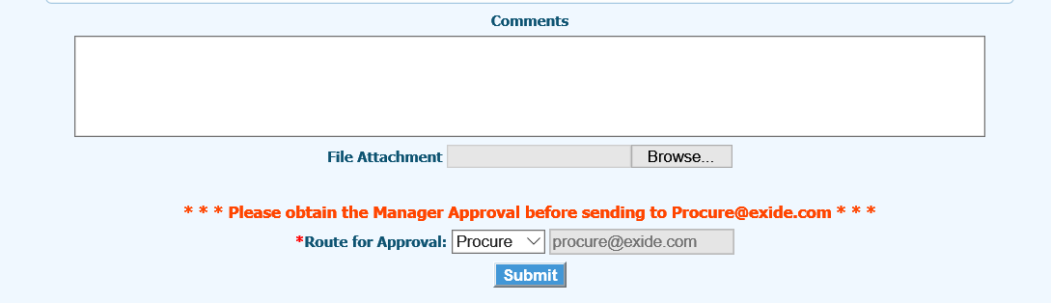

Make the following changes:

* **\* \* \* Please Route your request to your direct Manager or Departmental Admin \* \* \***
* **\* Rout for Approval:** Approver ⮛ email address

The final process still needs to go to [procure@exide.com](mailto:procure@exide.com) but not by default – only when they select no further approvers.